Quick Resolve/Complete Examples

# Incident:

Incidents are quite straight forward to setup a Quick Resolve ticket for, most of the work is done inside the template, and the custom code handles the rest.

First, create an Incident Template, pointing to the Incident Class.

In this example I will be doing a Quick Close for an account locked issue, a routine issue which has a quick and easy fix, but I don’t want to have to go back into the ticket straight after creating it to resolve it.

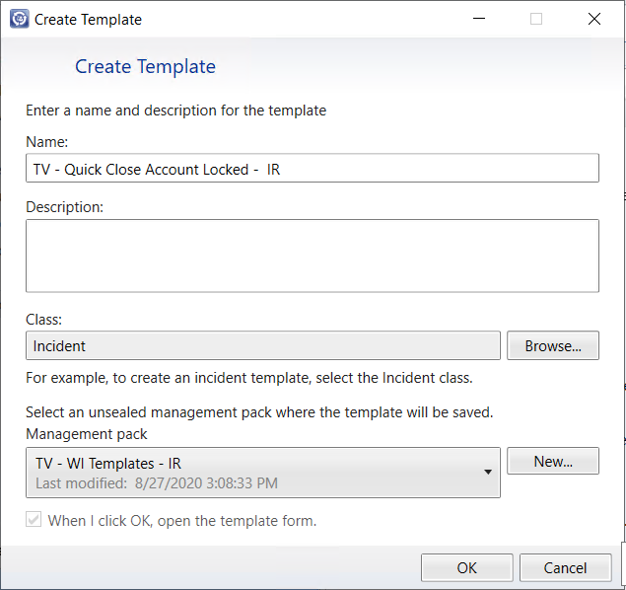

Next, fill out the standard details for the template that you would like to be capture. Then Click on the Change Status task on the right hand right, and click ‘Resolve’:

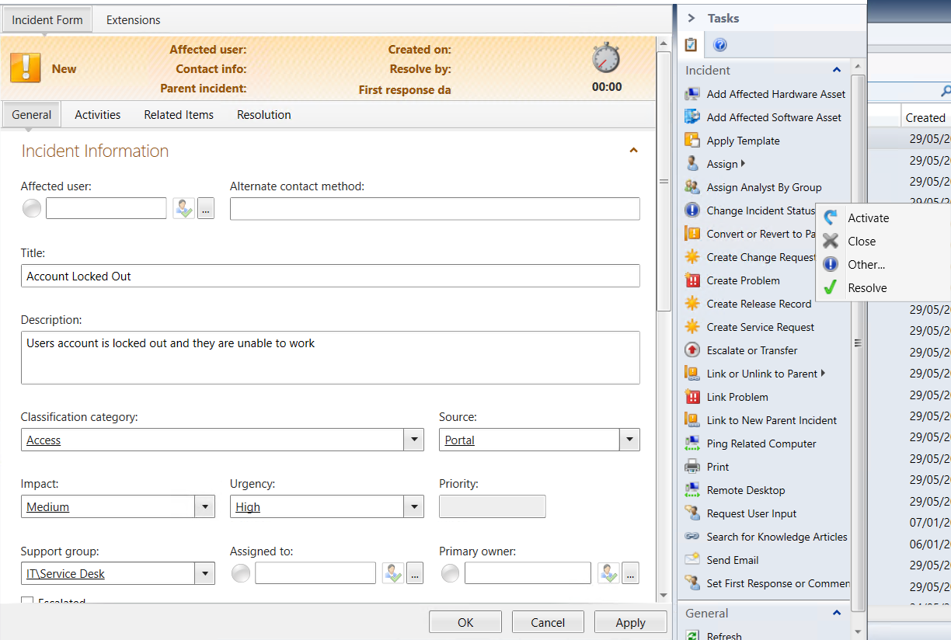

Now you will need to enter the information that you would like to be auto populated when the Incident is resolved, something generic that covers the resolution for the ticket. Make sure to set the Resolution Category and any comments:

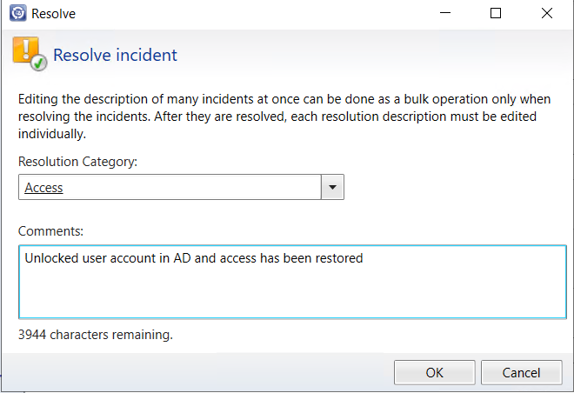

Once the Template is complete, saved all changes and head over to the portal.

Click on New > Incident > From Template and search for the template you just created.

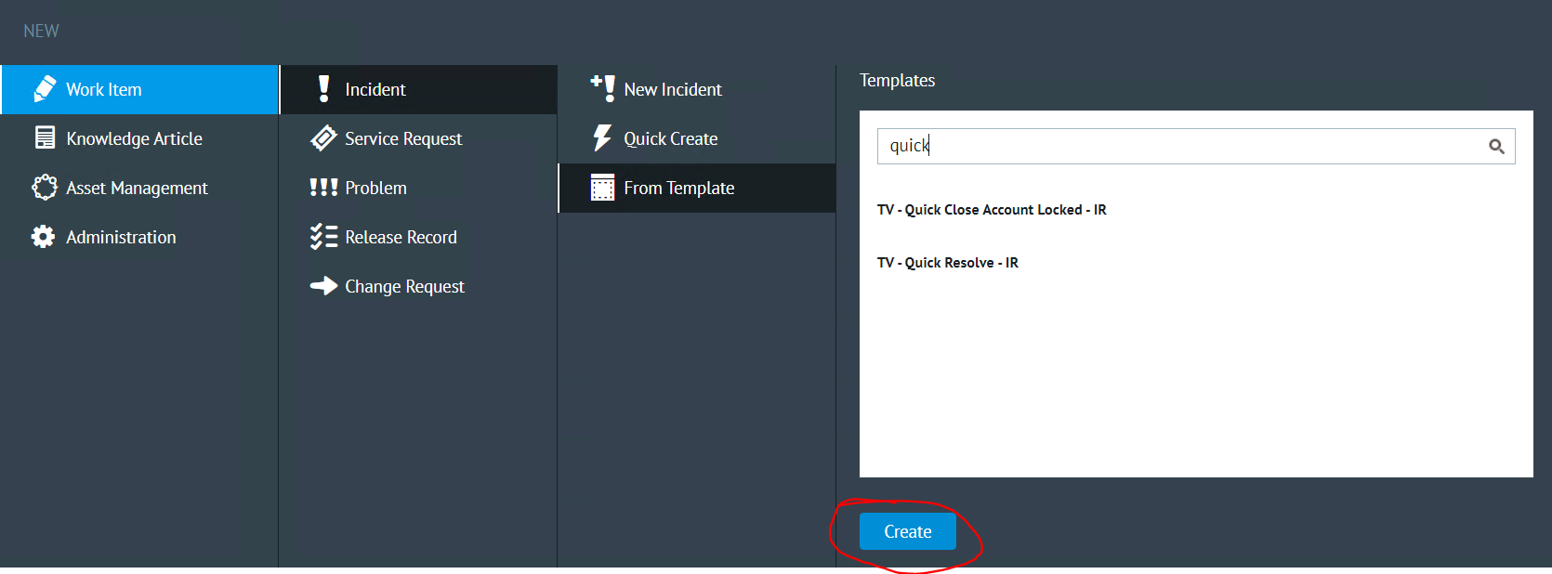

When the form is open, fill out any additional details like the affected user etc and apply the changes.

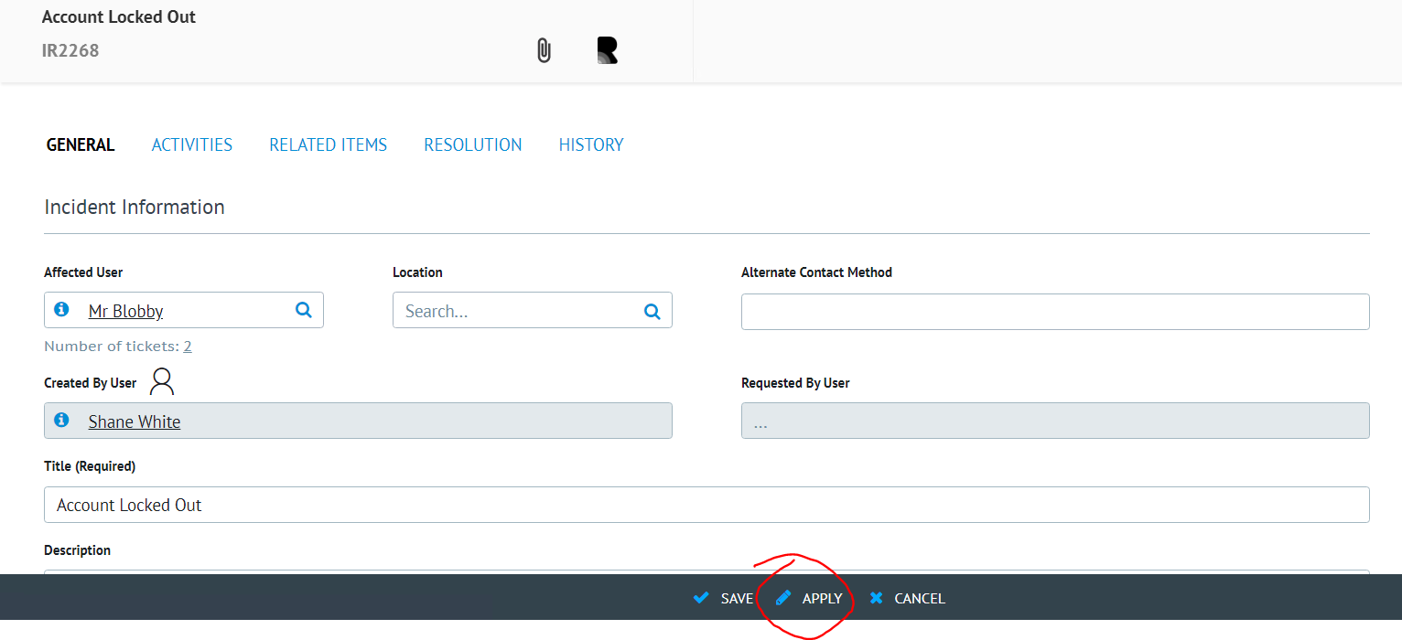

As you can see, when the page is reloaded, the New Incident has been automatically set to resolved, the Resolved Date has been populated (This is important for those using AutoClose) and the Resolved By User has also been populated.

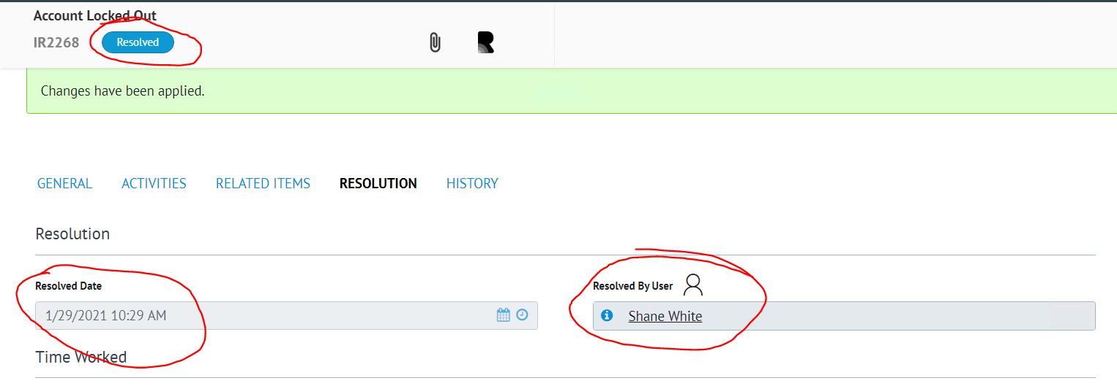

In addition, we can see all the same information being set if we looked at the ticket inside SCSM too.

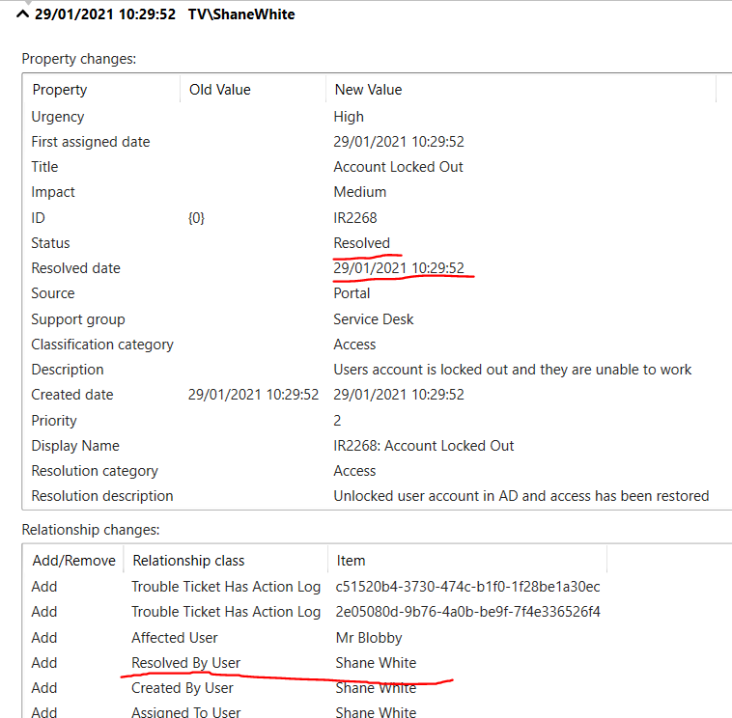

Therefore, we have been able to cut down the time spent on creating/resolving the ticket because you have been able to do all of it in 1 step rather than 2 or 3. And normally when doing this, you could click save, the ticket would redirect you to the page you were on before, and you can forget about it!

# Service Request:

Service Requests are a little bit different, but this is because they behave differently than an Incident. In this instance, you still make most of the changes in the template, but the custom code must do the work of changing the status since you cannot complete a Service Request in the template itself.

First, create a Service Request Template, pointing to the Service Request Class.

In this example I will be doing a Quick Close for a password reset request, a routine request which has a quick and easy fix, but I don’t want to have to go back into the ticket straight after creating it to resolve it.

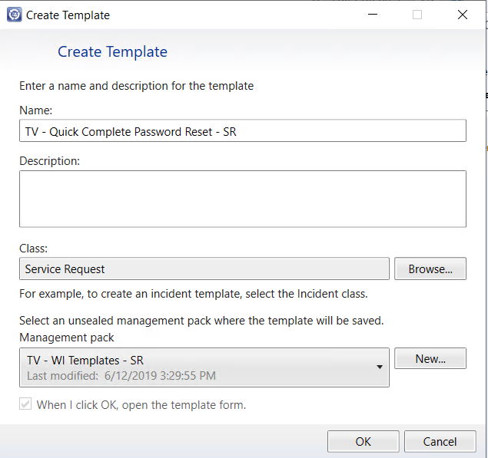

Now, same as we did for the Incident template, fill out the standard details for the template that you would like to be capture, but this time, head over to the Extensions tab:

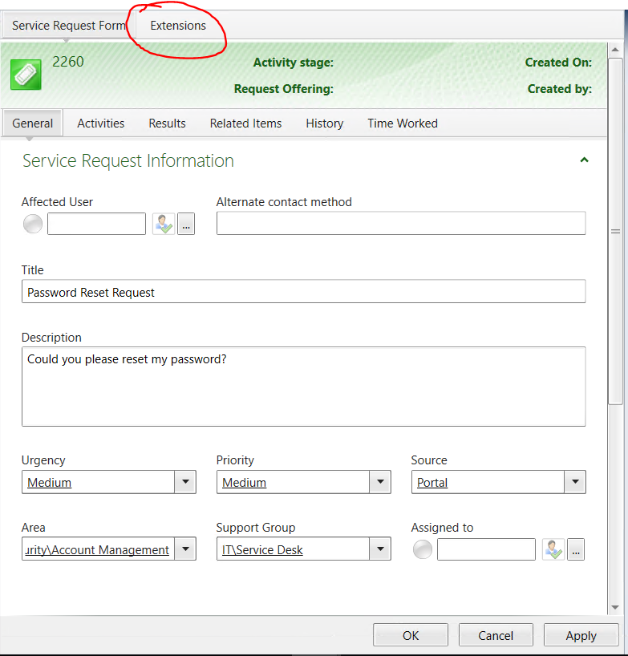

The part of this which is different is we now have an extended property which marks the Template as a quick complete template or not. If you want it to be a quick complete you must set the value to true, otherwise false, or null will not quick complete the ticket when it is created.

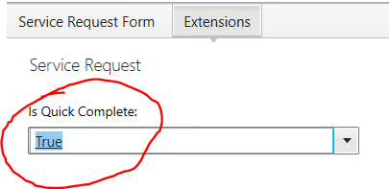

Next, go back to the Service Request Form, head to the Results tab and fill in the information to capture as seen in the below example:

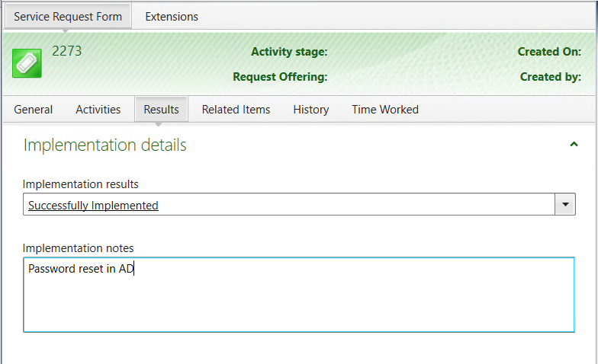

IMPORTANT NOTE: This solution is designed to work with Service Requests WITHOUT activities, so do not add any activities to the template

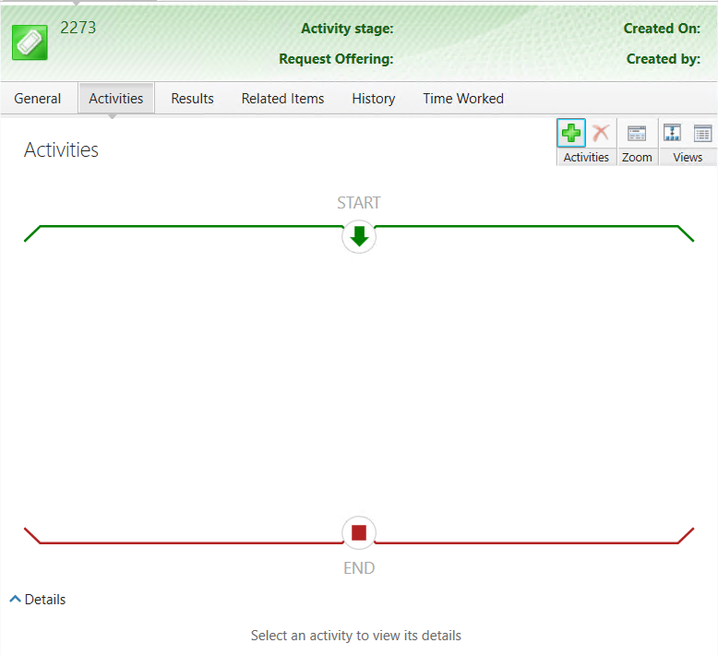

Once you have filled out all the required information, and ensured there are no activities on the template, head back over to the portal.

Click on New > Service Request > From Template and search for the template you just created.

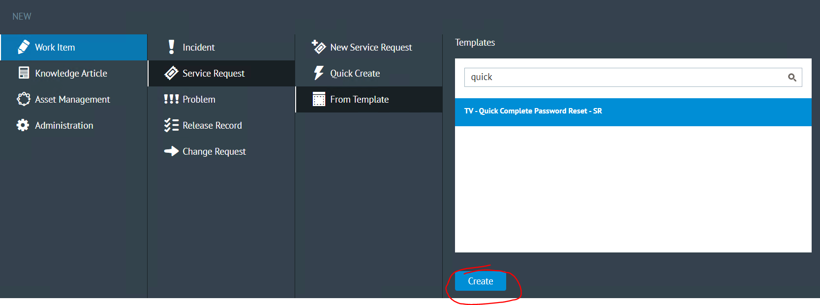

When the form is open, fill out any additional details like the affected user etc and apply the changes:

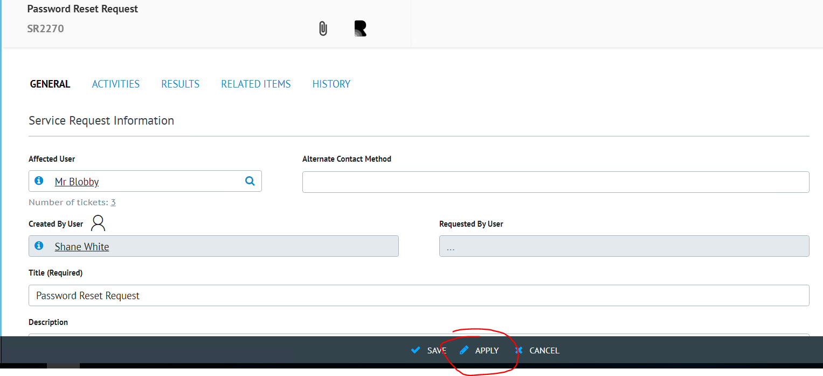

As you can see, when the Service Request has been saved, it is automatically set to complete, you do not need to wait for the workflow to run:

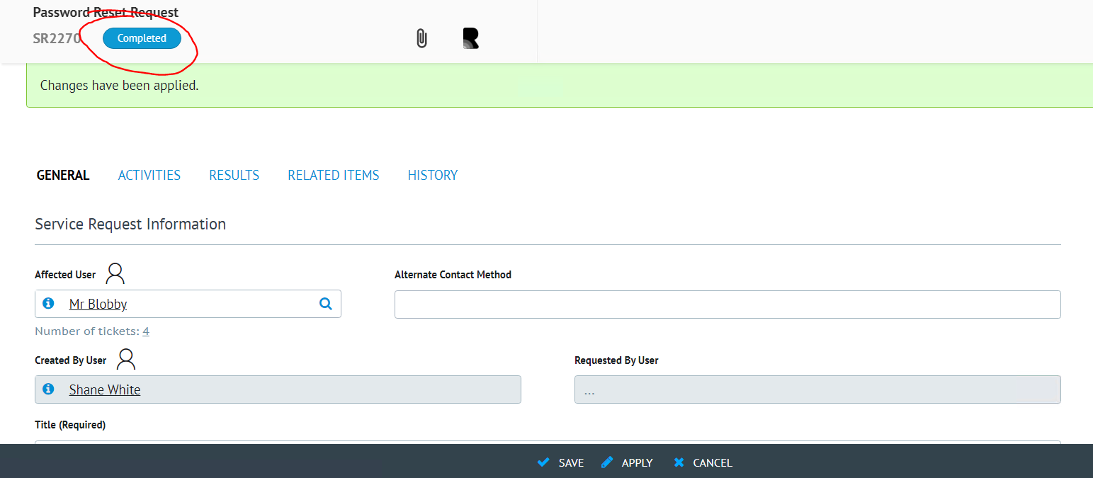

Again, if we head over to SCSM we can see that the Implementation results and notes have been auto populated, and from the history that the Completed Date has been set (Again, important for AutoClose) and the Status was set to completed.

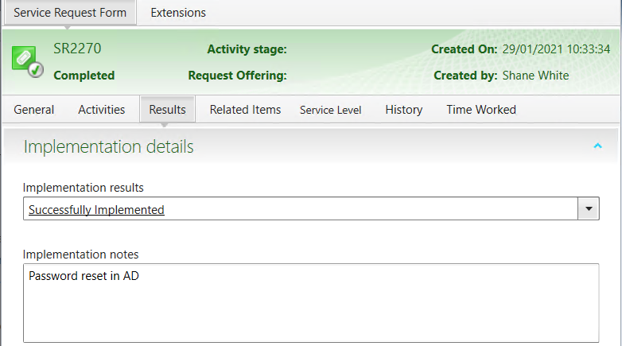

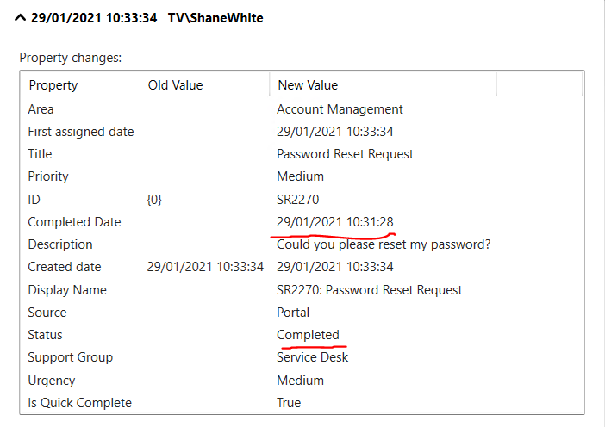

Therefore, we have been able to cut down the time spent on creating/completing this ticket because you have been able to do all of it in 1 step rather than 2 or 3 and you no longer have to wait for the workflow to change the status. And normally when doing this, you could click save, the ticket would redirect you to the page you were on before, and you can forget about it!